Sense-U Baby Monitor 3: User Manual

READ ME FIRST
- The Sense-U Smart Baby Monitor is not a medical device and is not intended for use in the diagnosis of disease or other conditions, or in the cure, mitigation, treatment, or prevention of disease.
- The Base Station needs to work with a 2.4GHz wireless network. Hotspot WiFi and 5GHz are not supported.
- Clip the Sense-U Baby device onto snugly fitting sleepwear (diaper/pants/etc), right next to the belly button.
- The baby icon should be orientated in the same direction as child’s body direction, to avoid incorrect position readings and false notifications.
- If the child sleeps on their side or stomach, the Sense-U Baby should be placed off center of the navel and the mattress. (Snugly fitting sleepwear is important to avoid false notifications.)
- Movement from external sources such as being pushed in a bassinet or traveling in a vehicle may be detected by the Sense-U Baby device. The Sense-U Baby Monitor should not be relied upon where external sources of movement are present.
- The monitored child must sleep in their own separate bed as the monitor may detect the movement of any other person sharing the bed with the child and will not send any notification as long as it detects movement.

What’s in the Box
Sense-U Baby Monitor Device
Sense-U Base Station
USB Power Cable
User Manual

QUICK START GUIDE

How it works?

How the Sense-U Monitor works
The Sense-U Smart Baby Monitor is comprised of a wearable Baby Monitor device, a Base Station, and a Sense-U Baby App. It is intended to be used by parents to monitor their child’s body movement (all types of body movements, including but not limited to, rotation, flexion,extension, abdominal movement, etc.), sleeping position, ambient (feeling) temperature around belly, room temperature, room humidity level as sleep quality indicators.

The Base Station is intended to provide notifications, such as no body movement within 20 seconds, sleeping on the stomach, ambient temperature around belly / room temperature / humidity level out of preset values, with light and sound notifications from the Base Station and mobile notifications from smartphone app based on the above sleep quality indicators, to support restful sleep for the child.
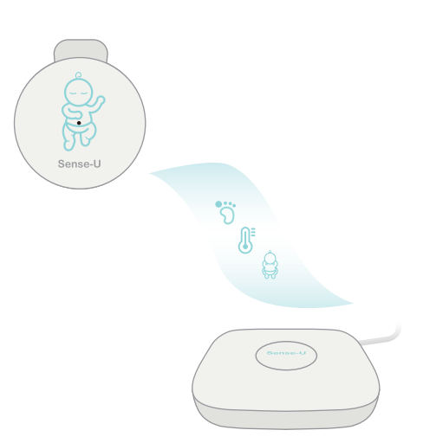

How the App works
The Sense-U Baby app is a mobile application that is intended to be used with the Sense-U Baby Monitor, provides readings of a child’s sleeping quality indicators, including body movement, sleeping position, ambient(feeling) temperature around belly area, room temperature, room humidity level. It also provides notifications to parents based on these sleeping quality indicators, to support restful sleep for their child. The Sense-U Baby Monitor is not a medical device and is not intended for use in the diagnosis of disease or other conditions, or in the cure, mitigation, treatment, or prevention of disease.
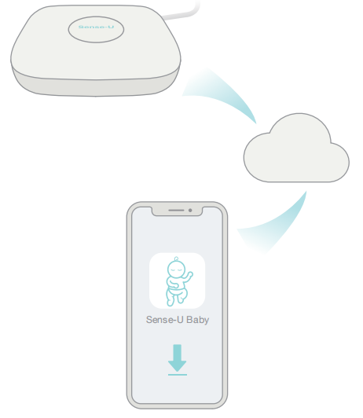

GHz WiFi Network:
The Base Station communicates with the Sense-U Cloud via 2.4GHz WiFi network. The Sense-U Cloud enables the sleep quality data to be shown in the app. This enables real-time readings and notifications on the app from anywhere.

Get to know your Sense-U Monitor

Sense-U Smart Baby Monitor
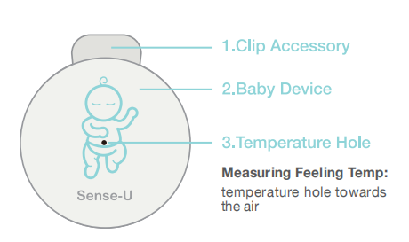
The Sense-U Smart Baby Monitor is a wearable baby monitor that securely attaches on your child’s sleepwear and conveniently monitors their body movement, sleeping position, temperature during sleep and sends notifications when something happens to your child, from anywhere.

Sense-U Base Station
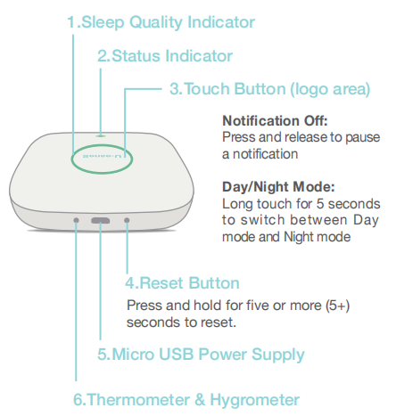

Set up the Sense-U Monitor

Requirements
A 2.4GHz WiFi wireless network is required. Hotspot WiFi and 5GHz WiFi network are not supported.
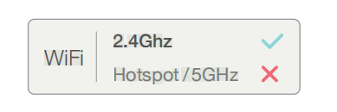
Turn on Bluetooth and keep your smart device next to the Sense-U Base Station during pairing.

Pull out the battery separator to power on the Baby device.
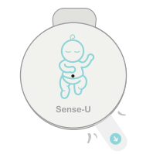
Power on the Base Station and ensure it flashes BLUE .
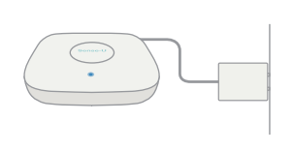

Download the Sense-U Baby App
- Download the free Sense-U Baby app, available for iOS and Android from Apple App Store and Google Play.
- Allow all requested permissions for the Sense-U app, e.g Location, Bluetooth, no optimization of battery usage, etc.
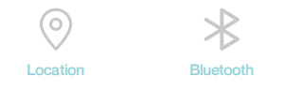

1.Create a free Sense-U account.

Pair the Sense-U Monitor
Follow the in-app instructions to pair the Base Station and Baby device accordingly.
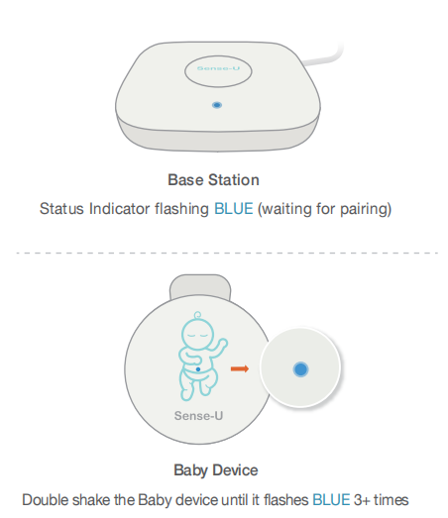

Fitting

Snugly Fitting Sleepwear
- Snugly fitting sleepwear (diaper/pants/etc) is essential for accurate monitoring. For optional wearing detection function working properly, the back of the clip needs to be in contact with child’s skin tightly.
- Loose fitting sleepwear may cause the monitor to lose contact with the child and introduce false notifications.
1.If the child sleeps on their side or stomach, the Sense-U Baby should be placed off center of the navel and the mattress. (Snugly fitting sleepwear is important to avoid false notifications.)
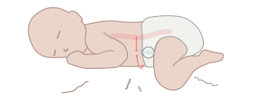

Measuring Temperature
Temperature tip towards the air
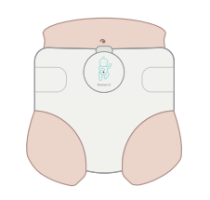
1.Attach the Sense-U Baby to your child’s waist, next to the belly button, and face the temperature hole towards the air for feeling temperature measurement.
1.Keep the baby icon in the same direction as your child's body direction to avoid unexpected readings and notifications.

How to Handle the Device

Wearing Instructions
To put on the device, snap the Sense-U Baby device, then push the clip accessory onto the diaper to the FULL extent of the clip.
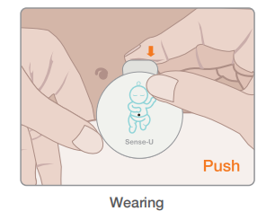
To take off the device, hold the waistband of the diaper, then pull the device out of the diaper.

Changing Battery
The Sense-U Baby device uses a CR2032 coin battery. The battery life is up to one (1) month, depending on the usage and other settings.
Tips:
Switching off the Baby device on the home page of the app can put it into power-saving mode and prolong battery life.
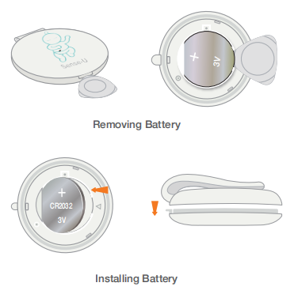

OPERATIONS

Indicator Lights
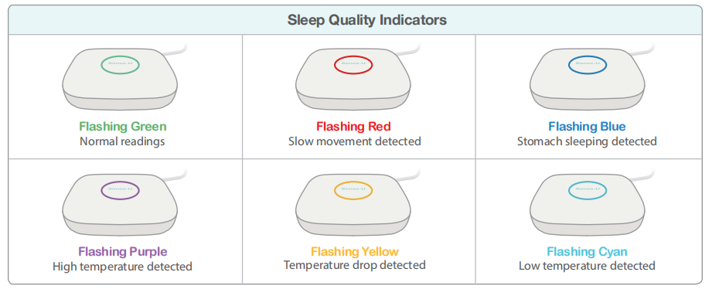

Sense-U App at a Glance
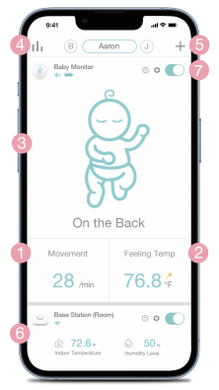

Home Screen

1.Movement Reading
< 5/min: Slow movement detected: Wiggle movement detected
Footprint Icon: Wiggle movement detected
OFF：Movement notification switched off
--(dash): Wearing detection(Beta) switched on.
* To show movement readings, the movement notification needs to switch on from the Sense-U Baby App->Baby Device Settings (setup icon on home screen)->Baby Notification.
1.Feeling Temp: Temperature tip towards the air
* It may take 30+ minutes before the displayed temperature becomes stable and ready to read.
- Sleeping Position: On the Back, Right Side, Sit Up, Left Side, On the Stomach
- Historical Stats: The historical data of child's movement, temperature, etc
- Add Device: entering Add Device page
- Base Station Section: Room Temperature / Room Humidity Level / etc
- On/Off Button
On: All baby notifications switched on
Off: All baby notifications switched off, entering power-saving mode.
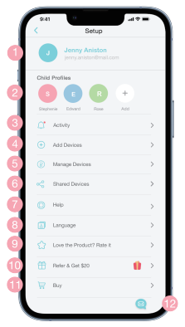

Setup
- My Profile: Update my profile, log out
- Child Profiles: Add child, Update child’s profile, delete child’s profile
- Activity: Activity list
- Add Devices
- Manage Devices: Change notification settings, check device information, update firmware, delete device
- Shared Devices: Share with family members
- Help: User manuals, feedback
- Language: English, Spanish, Germany, Japanese, etc
- Love the Product? Rate it: Like our product? Support us with a positive review
- Refer: Refer a friend and earn
- Buy: Find exclusive deals available in the Sense-U official store (www.sense-u.com)
- Feedback: Have questions about your Sense-U products? Contact us here and include your device / app info, which will greatly expedite the diagnosis process.
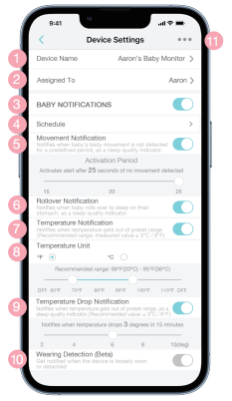

Device Settings
- Device Name: The name of your device
- Assigned To: A child, a nursery room, or any object that the device is used to monitor, or the location where the device is located
- Baby Notification: Turn on / off all baby notifications
- Schedule: Set schedules to make each device run according to your daily habits
- Movement Notification
On/Off: Movement notification needs to switch on to enable movement reading and notification
Activation Period: Adjust the period for different movement patterns

Rollover Notification
- Temperature Notifications
- Temperature Units: Fahrenheit / Celsius
- Recommended Value: Measured temperature +/- 3°C or 6°F
- Temperature Drop Notification
- Recommended Value: 3°C or 6°F
- Wearing Detection: Get notified when the device is loosely worn or detached
- Device Information
* To receive audible notifications, notifications need to be switched on for the Sense-U Baby app in Settings-> Notifications->Sense-U Baby and make sure your smart device is not in Do Not Disturb mode.
* For Android devices, make sure Media Volume is switched on in Settings->Sounds and Vibration->Volume.

MAINTENANCE
- The Sense-U Smart Baby Monitor is splash-resistant, NOT waterproof. Do not immerse in water. If it gets wet, dry it off immediately.
- Do not leave it in wet diaper for long time, it may cause unexpected temperature reading, or other malfunctions.
- Gently wipe with a damp cloth to remove any dirt.
- To prolong battery life, take off the Sense-U Baby device when it is not in use and turn off the device from the Sense-U app. Remove the battery if it is not in use for a long time.

TROUBLESHOOTING

1.Where should the Sense-U Monitor be worn?
Clip Sense-U onto your child's sleepwear (diaper/pants/etc), right next to the belly button. Snugly fitting sleepwear is essential for accurate monitoring.

1.What does double-shaking mean?
Shaking the Baby device twice to initiate Bluetooth pairing by flashing BLUE three or more (3+) times.

1.My device does not flash when I double shake it.
Replace with a new CR2032 coin battery. The device restarts with a GREEN light flashing once.

1.The Base Station is unable to connect to my WiFi network.
Make sure the WiFi password you entered is correct and the network connection is good. Move the Base Station and mobile device closer to the router and try again.
* Only 2.4GHz WiFi networks are supported (Hotspot WiFi and 5GHz WiFi are not supported).
1.The Baby device cannot pair to the Base Station.
STEP 1. Make sure the Base Station is flashing GREEN before double shaking the Baby device to pair. If not, add the Baby device again from the Sense-U App->Add Device (+ icon on home page).
STEP 2. If the Baby device does not flash when double shaking it, remove the battery and plug in again. Replace with a new battery until it flashes GREEN once to restart.
STEP 3. If the Baby device only flashes GREEN when double shaking it, it means it is already connected to the Base Station or another smart device. Delete the Base Station or log out that smart device first before pairing again.
STEP 4. If the Baby device flashes BLUE but is still unable to pair, check if Bluetooth is enabled on your smart device, then move the Baby device closer to the Base Station, and other Sense-U devices and Bluetooth devices away, and try again.
* For Android devices, please make sure Location is enabled all the time for the Sense-U Baby app in Settings->Connections->Location, and Settings->Apps->Sense-U Baby->Permissions. Or else it can not pair to the device and stay connected.
1.The Baby device shows as Disconnected in the app.
STEP 1. If the Base Station's indicator shows solid YELLOW dot, it means the Baby device is disconnected from the Base Station.
Check the battery level of the Baby device by double shaking the device to see if the indicator lights up, or from the Sense-U Baby App->Baby Device Settings (setup icon on the home page)->Device Information (three dot). Replace with a new CR2032 battery if necessary. Move the Baby device closer to the Base Station and it should be able to reconnect automatically.
STEP 2. If the Base Station's indicator shows a flashing GREEN circle, it means the Baby device is already connected to the Base Station. Refresh the app by tapping the On / Off button in the app, or by switching the app between foreground and background modes.
STEP 3. If the Base Station's indicator shows a flashing RED dot, it means the Base Station is unable to connect to the Sense-U Cloud server. Move the Base Station closer to your WiFi router.
STEP 4. If the Base Station does not light up and it is not in Night mode by tapping the Sense-U Baby App->Base Station Device Settings (setup icon on the home page)->Night Mode, unplug its power cable to restart.
1.There is no movement reading but dashes in the app.
Turn on the Movement notification from the Sense-U Baby App->Baby Device Settings (setup icon on home screen)->Baby Notification and the movement reading will show up shortly after it detects movements. For optional wearing detection function working properly, the back of the clip needs to be in contact with child’s skin tightly.
1.The device goes off while my child looks fine.
Make sure the device is clipped on snugly fitting sleepwear following the instructions. Meanwhile, you can increase the Activation Period from the Sense-U Baby App->Baby Device Settings (setup icon on the home page)->Baby Notifications-> Activation Period for slower movement patterns.
1.There is no sound from my smartphone when notifications show up.
To receive audible notifications on your smart device, your smart device should not be in Do Not Disturb mode, and notifications need to be enabled for the Sense-U App in Settings->Notifications->Sense-U Baby. For Android devices, turn on and increase Media Volume in Settings->Sounds & Vibration->Volume.

DISCLAIMER
The Sense-U Baby Monitor is not a medical device and is not intended for use in the diagnosis of disease or other conditions, or in the cure, mitigation, treatment, or prevention of disease. Customers use this monitor at their own risk and Sense-U Inc., its members, employees, agents, contractors, representatives, manufacturers, distributors and associates shall not be held liable for any loss, damage or injury suffered by the customer or any other person arising from, or in connection with, the use or manufacture of the monitor, including loss, damage or injury suffered by the customer or any other person as a result of any defects in respect of the monitor, and all warranties, and any other liability from whatsoever cause arising, are hereby excluded and the customer hereby indemnifies Sense-U Inc. in respect of any such liability.

GUARANTEE
Sense-U promises a 30-day Money Back Guarantee for this product and a 1-year Limited Warranty from the original date of purchase, verified by a sales receipt. Our warranty liability shall be limited to replacing the unit free of charge and does not include transport costs. Our guarantee extends to all countries in which this product is supplied. By the act of operating this product, the user accepts all resulting liability. We reserve the right to modify the provisions of this guarantee at any time without notice. This guarantee does not cover the battery, incorrect application, tampering, misuse or transport damage.
*Avoid sandwiching clothing or other material between the clip / ring accessory and the monitor device. It may break the accessory and introduce false notifications at your own risk.

CONTACT US
For product questions, we recommend contacting us directly via in-app Feedback following the Sense-U Baby App->Setup-> Help->Feedback. It includes your device / app information and will greatly expedite the diagnosis process. For general questions, please email us at SUPPORT@SENSE-U.COM.

